An Unsupervised Aspect-Sentiment Model for Online Reviews

1 Introduction

In this paper, we present an unsupervised system which addresses the core tasks necessary to enable advanced applications to handle review data. We introduce a local topic model, which works at the sentence level and employs a small number of topics, to automatically infer the aspects. For sentiment detection, we present a method for automatically deriving an unsupervised seed set of positive and negative adjectives that replaces the manually constructed ones commonly used in the literature. Our approach is specifically designed to take into account the interaction between the two tasks.

2 Previous Approaches

3 Data

4 Aspect

4.1 Methodology

Local LDA

Model Order

The issue of model order, i.e., determining the correct number of clusters, is an important element in unsupervised learning.

We then employ the following procedure:

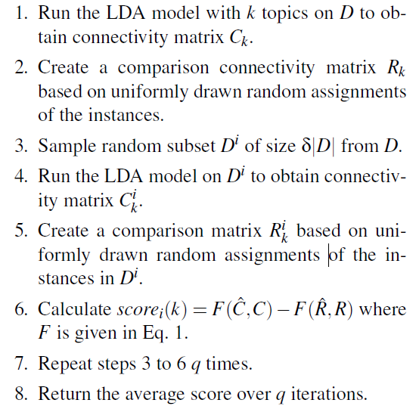

Determining Representative Words

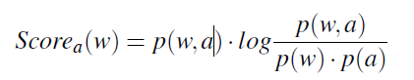

4.2 Inferred Aspects

4.3 Evaluation

5 Sentiment

For determining sentiment polarity, we developed the following procedure. For each aspect, we extracted the relevant adjectives, built a conjunction graph, automatically determined the seed set (or used a manual one, for comparison), and propagated the polarity scores to the rest of the adjectives.

5.2 Aspect-Specific Gold Standard

5.3 Evaluation Measures

5.4 Evaluation Results

6 Discussion & Future Work

The aspects are inferred from the data, and are more representative than manually derived ones.